**1. Changes in net worth**

From the following table of transactions between two users, write a query to return the change in net worth for each user, ordered by decreasing net change.

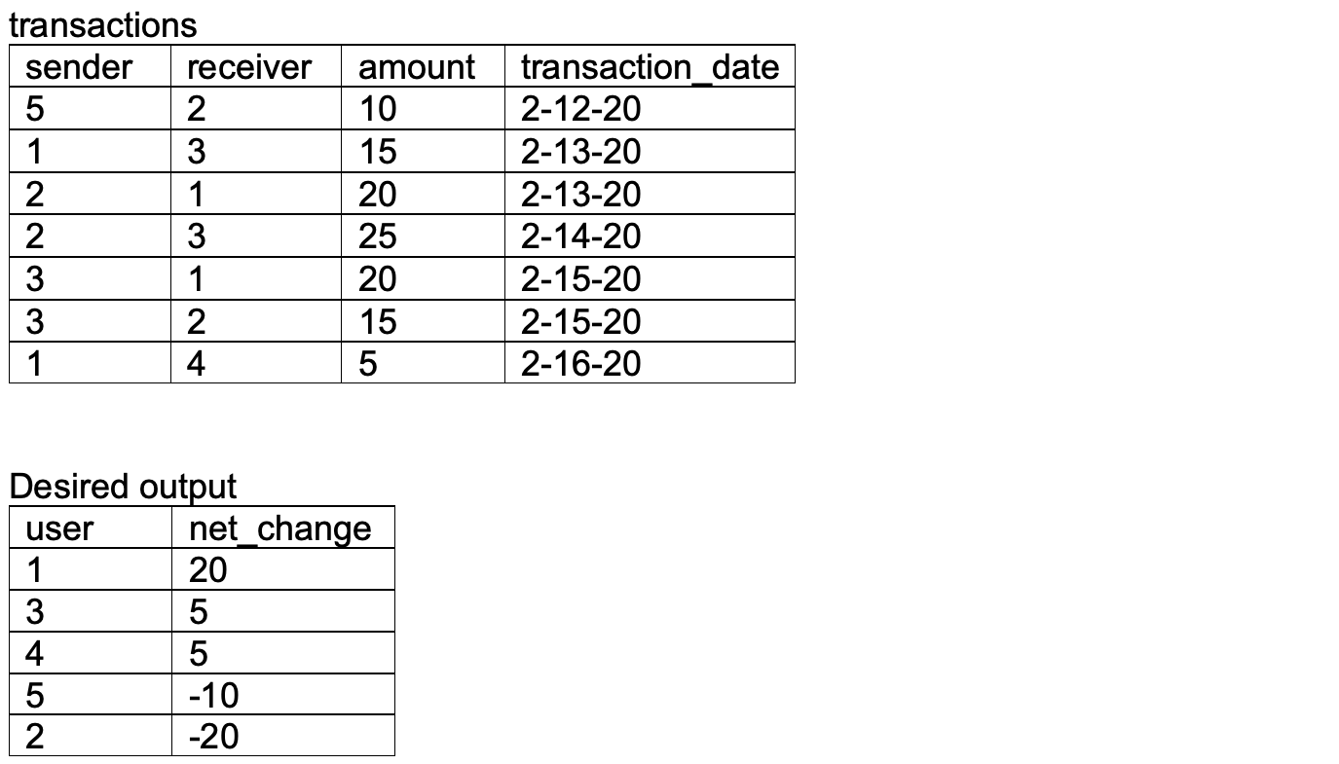

1. Create above table (transactions) with “with” clause,
2. Sum amounts for each sender (debits) and receiver (credits),
3. Full (outer) join debits and credits tables on user id, taking net change as difference between credits and debits, coercing nulls to zeros with coalesce()

## **2. Birthday attendance**

Given the following two tables, write a query to return the fraction of students, rounded to two decimal places, who attended school (attendance = 1) on their birthday.

attendance

|  |  |  |
| --- | --- | --- |
| student_id | School_date | attendance |
| 1 | 4-3-20 | 0 |
| 2 | 4-3-20 | 1 |
| 3 | 4-3-20 | 1 |
| 1 | 4-4-20 | 1 |
| 2 | 4-4-20 | 1 |
| 3 | 4-4-20 | 1 |
| 1 | 4-5-20 | 0 |
| 2 | 4-5-20 | 1 |
| 3 | 4-5-20 | 1 |
| 4 | 4-5-20 | 1 |

students

|  |  |  |  |
| --- | --- | --- | --- |
| Student_id | school_id | grade_level | date_of_birth |
| 1 | 2 | 5 | 4-3-12 |
| 2 | 1 | 4 | 4-4-13 |
| 3 | 1 | 3 | 4-5-14 |
| 4 | 2 | 4 | 4-3-13 |

Desired_output

|  |
| --- |
| Birtday_attendance |
| 0.67 |

1. Create above tables (attendance, students) with “with” clause,
2. join attendance and students table on student ID, and day and month of school day = day and month of birthday, summing ones in attendance column, dividing by total number of entries, and rounding